|  |  |  |  |
| --- | --- | --- | --- |
| **Name** | **Pratik Pujari** | | |
| **UID no.** | **2020300054** | **Class:** | **Comps C Batch** |
| **Experiment Aim:** | To Find Rank of a Matrix using SciLab and Manually | | |

**Introduction to SciLab**

Scilab is a programming language associated with a rich collection of numerical algorithms covering many aspects of scientific computing problems. From the software point of view, Scilab is an interpreted language. This generally allows to get faster development processes, because the user directly accesses to a high level language, with a rich set of features provided by the library. The Scilab language is meant to be extended so that user-defined data types can be defined with possibly overloaded operations

**Capablities of SciLab**  
  
• Linear algebra, sparse matrices,

• Polynomials and rational functions,

• Interpolation, approximation,

• Linear, quadratic and non linear optimization,

• Ordinary Differential Equation solver and Differential Algebraic Equations solver,

• Classic and robust control, Linear Matrix Inequality optimization,

• Differentiable and non-differentiable optimization,

• Signal processing,

• Statistics

**How to Install SciLab:**

* Visit the site <http://www.scilab.org/download> to download the latest version of SciLab software
* There are three different platforms supported by SciLab (Windows, Linux, Mac Os)

**Some Basic Commands to write in console:**

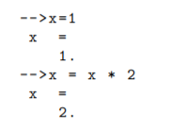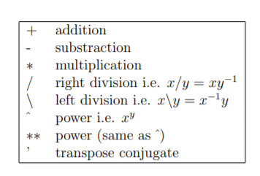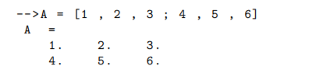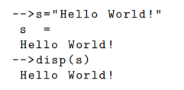

**Question 1:** Find the Rank of the Given Matrix A in the below Question?

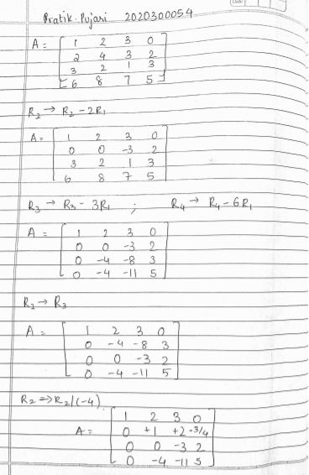

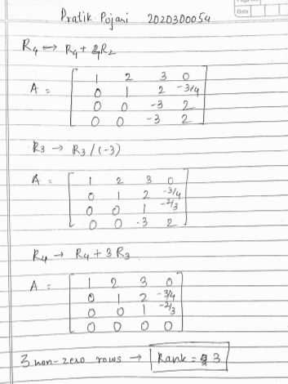

Therefore by using elementary row operations we get Rank =4 for the given matrix

Using the SciLab Software to find the Rank of the Matrix

* Declaring the Matrix A   
  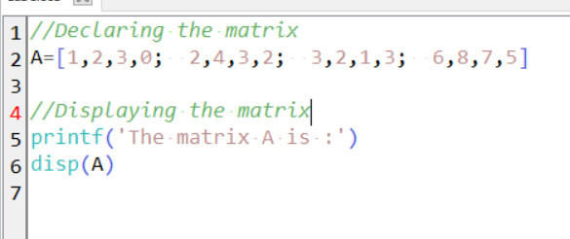  
  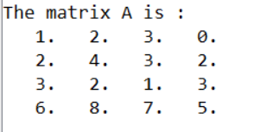
* Performing the Elementary Row Operations  
  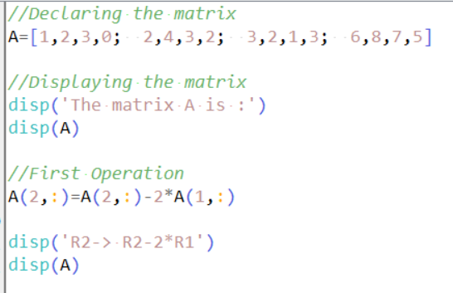

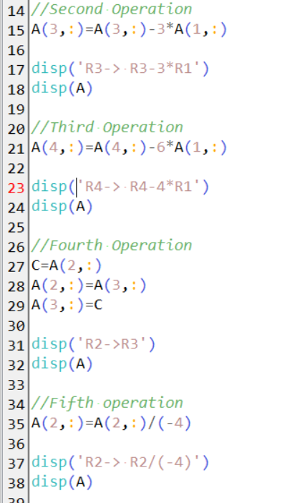

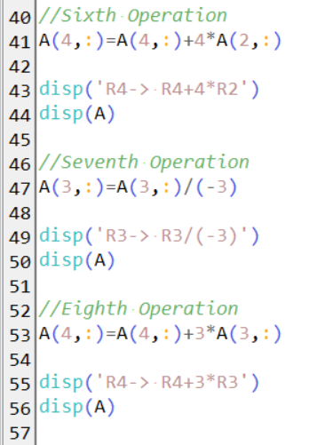

* Final Result

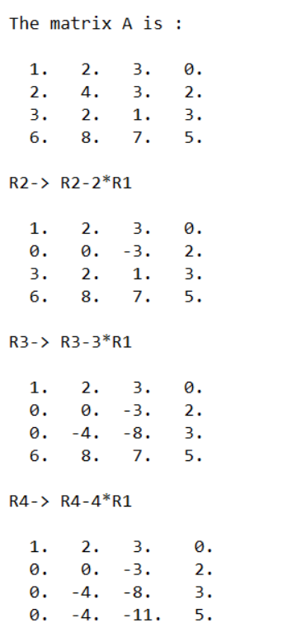

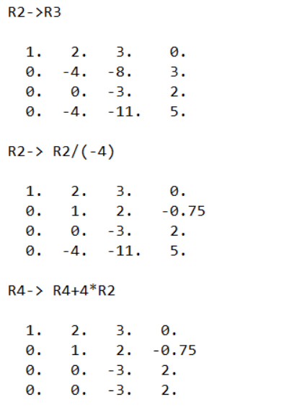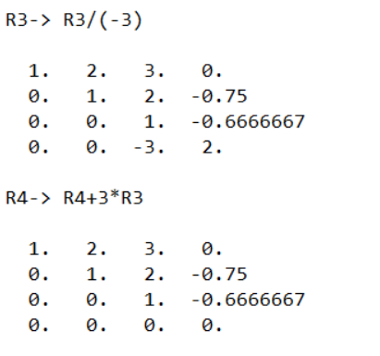Therefore Rank=4.Same as Above

**Conclusion**: Learnt to use SciLab basics and to find Rank of an given matrix using both Maths as well as Software